***Science***

***trance***

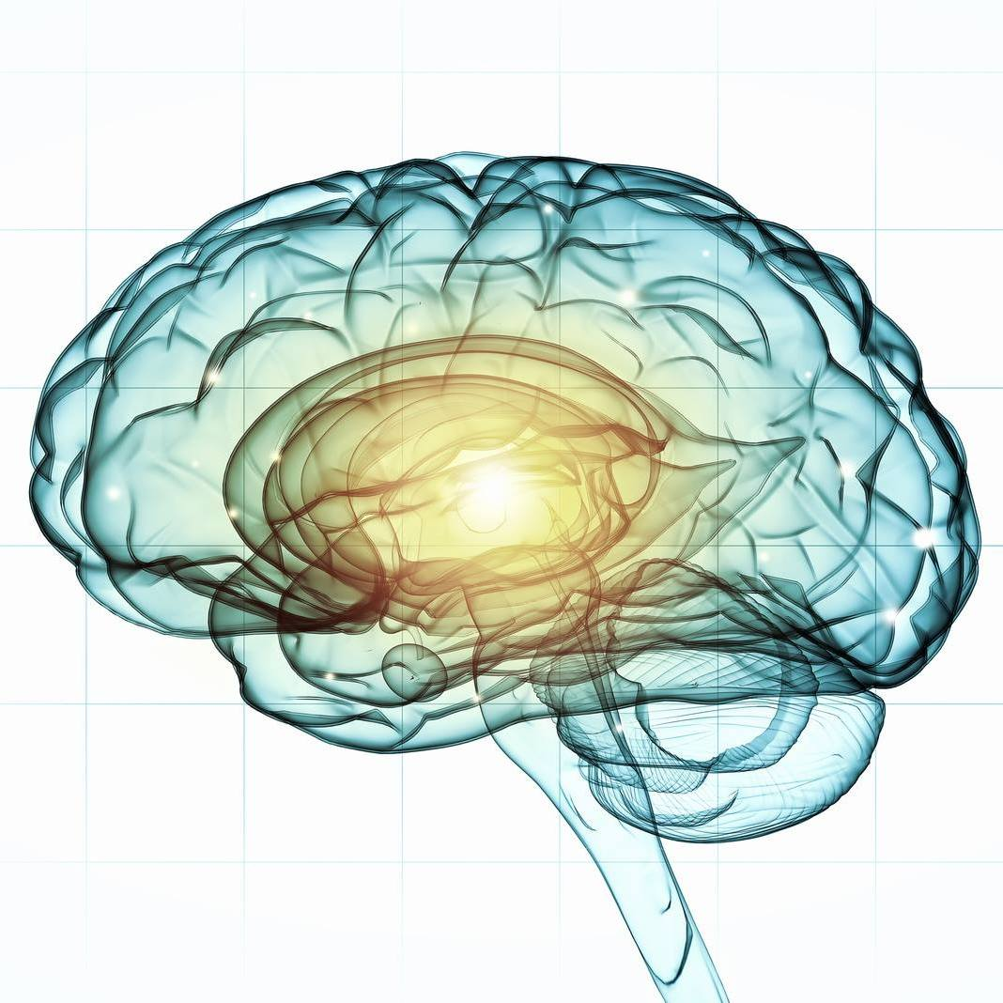

**TranceScience Research Institute**

**Scientific Background**

Trances practices, types, sort of studies

Our normal waking consciousness, rational consciousness as we call it, is but one special type of consciousness, whilst all about it, parted from it by the flimsiest of screens, there lie potential forms of consciousness entirely different. ... No account of the universe in its totality can be final which leaves these other forms of consciousness quite discarded. How to regard them is the question, for they are so discontinuous with ordinary consciousness. (William James, “Varieties of religious experience”, 1902)

The category of *altered states of consciousness* (ASCs), to which trance experiences belong, forms the second domain of conscious experience in addition to ordinary states of consciousness (OSCs). Trance is defined *as* a “temporary marked alteration in the state of consciousness or loss of customary sense of personal identity” (International Classification of Disorders, 1992), which can be either normative or pathological. The normative end of the ASC spectrum involves alterations in the auto- biographical sense of self, from expanded states of absorption (such as creative flow and meditative practices) to hypnotic trance; culture- and religion-specific practices including shamanic states of consciousness (SSC); and various modes of extra-sensory perception. Drug-induced psychedelic trances, synesthesias, savant capacities, and near-death experiences lie in the middle of the scale, while pathological ASC conditions include dissociative trance disorder, lycanthropy and related cultural practices, dissociative conditions such as Dissociative Identity Disorder (DID) and psychogenic fugues, and neuropsychiatric syndromes, such as temporal lobe epilepsy, schizophrenia, and affective psychoses where the sense of self may be radically altered or lost. One important corollary is that trance and altered states are not necessarily associated with psychopathology and may in fact be therapeutic (Money, 2000).

Both ordinary and altered domains of conscious experience can be conceptualized as a function of arousal vs. absorption extending from normality to psychopathology (Figure 1). The *arousal axis* extends from sleep and dreaming to normal wakefulness to heighted excitement and pathological self states involved in catatonia or manic psychosis. The orthogonal *absorption axis* incorporates normative self states of relaxed wakefulness progressing to focused attention, and pathological states of derealization/depersonalization, autoscopy, dissociative fugue, and DID. While the normal autobiographical self is identified with the dominant linguistic hemisphere (left in dextral population), there is evidence that some of the “altered states” phenomena may result from intrusions of non-dominant right hemispheric content into waking awareness (Persinger, 1993).

Contrary to the prevalent Western belief, ASCs are extremely common: anthropological studies show that of the 488 societies studied worldwide, over 90% were found to have an institutionalized form of ASCs, and 57% of these were possession trances (Oohashi et al., 2002). A recent cross-sectional study of normal British population (Pechey & Halligan, 2012) estimated the prevalence of anomalous experiences at 48%. Culture-bound religious and/or spiritual beliefs are a major factor determining their specific context. Within a particular social group, altered states can be experienced as either pathological (such as possession trance) or beneficial (such as meditative and shamanic practices). In fact, from the perspective of some meditative practices such as Zen Buddhism, it is the normative “dual” state of consciousness that fragments our perception into inner and outer reality and contributes to suffering and psychopathology. The expressed goal of many meditative practices therefore lies in achieving a non-dual state of unitary awareness (Berman & Stevens, 2015). Conversely, the Western rational tradition tends to pathologize ASC phenomena based on reductionist and behaviorist medical models, although there has been an increasing number of anthropological and neurobiological studies in recent years attempting to clarify their normative phenomenology and neurobiological mechanisms (Jilek, 2005; Vaitl et al., 2005).

There is a common mode of consciousness that may serve to bridge ordinary and altered self- experience. It is related to various types of focused attention, where conscious awareness is narrowed on either inner or outer content to the exclusion of wider self/world awareness*.* These states range from the everyday experience of focusing on a task at hand; to absent-mindedness (internal focus to the exclusion of environmental cues); to peak experiences and “flow states” *(*Csikszentmihalyi, 1996) linked to creativity or musical performance; to hyper-focused attention practices such as meditation and hypnotic trance. Narrowed attention states can be conceptualized as a form of “normative dissociation” induced by either external triggers or internal-imaginative processes (Seligman & Kirmayer, 2008).

Psychoevolutionary understanding of normative dissociation states suggests an adaptive function akin to the “freezing” response in dealing with inescapable threat, where neither fight nor flight alternatives are available. The resultant uncoupling from self/world awareness results from a deficit in normal integration of perceptions, feelings, thoughts, and experiences into verbal reflective consciousness, with consequent alterations in the coherent autobiographical narrative self. Dissociative states dampen autonomic and emotional reactivity, resulting in a combination of focused hypervigilance characterized by “simultaneous multisensory scanning of relevant information from the environment” while detaching from one’s self and the world at large, which may manifest as depersonalization/derealization (Seligman & Kirmayer, 2008). Experiences of early physical or psychological trauma may facilitate the development of dissociative defenses leading to trauma spectrum disorders, such as predisposition to chronic/complex post-traumatic stress disorder (PTSD, Herman, 1992), borderline personality states, and dissociative spectrum syndromes such as psycho- genic amnesias and DID. It is important to note that such dissociative processes are characterized by *both* deficits in normative integration of self/world experiences *and* rich internally driven imagery, which can be experienced in multiple sensory modalities. In discussing the traumatic etiology of pathological trance states, Castillo (2003) notes:

Some people can withdraw from reality by means of profound spontaneous trances, usually secondary to stress or psychological trauma, and create a fantasy experience by narrowly focusing their attention on imaginary structures or remembered traumatic events while blocking out external reality. (pp. 13–14)

The International Classification of Disorders (ICD) first listed the proposed criteria for Dissociative Conversion Disorder in 1989, and officially included it in ICD-10 (1992). The Diagnostic and Statistical Manual of Psychiatric Disorders (DSM) listed a proposed diagnosis of Dissociative Trance Disorder in DSM-IV (1994). Both classifications differentiated between trance and possession (defined as “single or episodic alteration in the state of consciousness characterized by the replacement of customary sense of personal identity by a new identity... attributed to the influence of a spirit, power, deity, or other person”). To be considered pathological, trance and possession states must occur involuntarily, cause significant distress or impairment to the individual, and not be a part of a culturally or religiously accepted practice. A comprehensive literature review by During, Elahi, Taieb, Moro, and Baubet (2011) for the period between 1988 and 2010 identified 402 case reports satisfying the criteria for DTD, with a 2:1 predominance of possession subtype (69%), a mean age of 25.2 years at the time of the first episode, and equal sex ratio.

A critical distinction between normative vs. pathological ASCs is the capacity for voluntary control in the service of a specific goal (Etevenon, 2010). This is one of the distinguishing features of meditative, shamanic, and other non-pathological trance states. Specifically, the historic ability of shamanic practitioners to enter trance as a way of bridging systemic social interactions with their increasingly complex inner representations distinguishes them from dissociative or psychotic conditions. In spite of an earlier tendency to label shamanic experiences as primitive and pathological, later studies link them to cohesion and evolution of sociability in tribal groups (Krippner, 2002; Stephen & Suryani, 2000). The resulting integration of cognitive and intuitive modes of experience may have promoted the evolution of culture and religion as we know them today (Winkelman, 2010).

From Shamanic Trance to Cognitive Trance: emergence of self-induction without external stimulus

The subject and one the authors (C.S) is an only child born in Draguignan, in the south of France. She spent her early years in Ouagadougou (Burkina Faso) in Africa. She underwent a near-death experience in Africa at the age of 11 months due to an allergic reaction to smallpox vaccine. After her parents’ divorce at the age of eight, she was raised by her mother in France; her father stayed in Africa and she visited him for summer holidays. She studied musicology, piano, and composition, and after winning national and international competitions in 1986, she received a scholarship from the Franco-Quebecois Youth Office to study with multimedia performers and composers in Montreal.

Following a traumatic episode in 1999 when her partner of 10 years died, she moved to London, England where she pursued a career as a pianist/composer and worked as a reporter for BBC World Service. In 2001, during a report on Mongolia (“Mongolian mysteries” aired on BBC World Service in 2002), the sound of a shamanic drum induced a violent crisis when she could no longer control her movements. A Dakhad shaman (one of the 31 ethnic Mongolian groups) recognized her as having unique shamanic gifts and invited her to apprentice for Shaman training (Sombrun, 2004). She traveled to Mongolia near the Siberian frontier for the following eight years, being taught shamanic practices by an ugdan Enkhetuya belonging to the Tsaatans ethnic group. In 2009, C.S became the first Westerner to achieve the status of *udgan* herself.

In 2005, C.S traveled to New Mexico to meet with Harlyn Geronimo, a medicine man and great-grandson of the famous Apache warrior. According to the Apache legend, this Indian tribe had originated in Mongolia (this is consistent with paleoanthropological and genetic data on the Bering land bridge migration route from Eastern Siberia to Alaska between 12,000 and 14,000 years ago—Wang et al., 2007). In 2008, C.S continued with her research on the migration of Mongolian tribes and went to Alaska where she met Athabascan Indians, presumed ancestors of the Apaches and descendants of the Mongols.

C.S. first experienced a spontaneous trance at the age of six, when she and her parents were attending a tribal funeral ceremony in Burkina Faso. She remembers being completely absorbed by the music, her mother later telling her that she began to shake, which spread to all of her body. Following her spontaneous trance experience in Mongolia, she came to Dr Etevenon who introduced her to Prof. P. Flor-Henry’s Clinical Diagnostic and Research Centre at Alberta Hospital Edmonton in Canada in an attempt to elucidate the physiological mechanisms underlying her ability to induce a shamanic trance.

C.S continues to compose music, give lectures, and research the mechanisms of SSCs. She is involved in ongoing research in trance states with Pr Edward Frenkel (University of California, Berkeley, USA), Pr Francis Taulelle (KU Leuven, Belgium), Pr Patrick Lemoine (Lyon University, France and Peking University, China) and Pr Marc Henry (Strasbourg University, France). She designed a digital soundtrack with Elie D. Lequemener modeled from original musical pieces played to induce trance by shamans. During a course on trance and creativity in December 2015, it was played to students of Beaux-Arts in Nantes, with 80% students undergoing a trance induction (instead of 0,001% with the traditional Mongolian drum) and subsequently returning to their normal state. Follow-up study is presently in progress. These findings demonstrate that trance states may be much more common than what is generally accepted, representing an underused potentiality rather than an exceptional gift or psychopathology.

Trance studies from a non-ethnographical or anthropological angles

The diverse levels of evidence reviewed to this point range from phenomenological accounts of altered states to anthropological and ethnocultural observations to electrophysiological and neuroimaging data. Brain neuroplasticity stands at the crossroads between subjective and cultural experience, allowing us to conceptualize an emergent discipline of *neuroanthropology*. In his recent review, Northoff (2010) commented that there *is* “bidirectional traffic between subject and environment that is mirrored in brain’s neuronal activity... which allows ourselves to constitute ourselves as humans and to create the different environments investigated in anthropology” (p. 749)*.* The challenge for the general reader and researcher alike is to integrate these highly specialized threads into an integrated model that may shed light on the mechanisms of trance and ASCs.

Northoff and Heinzel (2006a) made a seminal distinction between conventional “third-person neuroscience” focusing on observable changes in brain function vs. “first-person neuroscience,” in which the contents of the subjective experience are carefully linked to objective observations on a case-by-case basis. They comment that “empirical investigations of brain states focus exclusively on neuronal states and presuppose therefore only the third-person perspective”; however, “in order to reveal the true neuronal correlates of mental states, first- and third-person perspective must be linked to each other, resulting in the systematic ‘science of experience’.” In utilizing this paradigm, we offer parallel subjective and objective correlates of the subject’s shamanic trance experience, which will serve as a foundation for the integrated psychobiological model of *SSC*, and by extension the entire category of altered states and their relation to normative conscious processes.

A large variety of Cognitive Expansion of Consciousness : psycho-healing, physical healing, cognitive channeling…

While shamanic practices are diverse and may include the use of psychoactive drugs (such as ayahuasca and peyote), drumming, dancing, or environmental triggers (such as Native sweat lodge ceremonies), one common pathway involves the phenomenon of a “shamanic journey”—the intentional induction of an altered state of consciousness to facilitate individual growth or adaptive functioning in a tribal group.

The phenomenon of a “shamanic call”, or initiation into the shaman’s role, is worth mentioning here. Several common pathways have been described in the literature including a violent personal crisis, intense anxiety, and social withdrawal accompanied by “dreams, visions or inner voices” (Wright, 1989). While in the Western cultures these symptoms may accompany the prodromal phase of a psychotic illness, a tribal group member identified to possess “shamanic gifts” would then proceed with shamanic initiation and training. There is evidence that shamanic trance capacity is not culture-bound but may represent “an inherent psychobiological predisposition ... perhaps universal in the species” (Noll, 1983). One of the authors (C.S) has been researching digital musical loops derived from the shamanic drum beat, and achieved over 80% trance induction response in normal college population. In fact, the ability to convert sensorimotor imagery into symbolic stories inherent in shamanic practices may have been pivotal to the gradual emergence of abstract thinking and the evolutionary success of *Homo sapiens sapiens* (Krippner, 2000).

A large variety of activities in different fields:

There is extensive data involving lateralized effects in altered self experience. Right hemisphere activation has been linked to a diverse range phenomena including autoscopy, depersonalization/de-realization, out-of-body experiences, and voluntarily altered states such as self-dissolution meditation (Lehmann et al., 2001). Persinger (1993) used the construct of *vectorial cerebral hemi-sphericity* to provide neurophysiological evidence for right hemispheric intrusion phenomena, which are perceived as subjectively ego-alien, coming as it were from “outside” of the conventional left hemispheric, linguistically based mode of self-awareness. He states: “The right hemispheric intrusions are experienced as sensed presences that are described as ‘impressions’, ‘entities’, ‘ghosts’, ‘old hags’, cosmic consciousness and spiritual beings; the experiences are maximally affective and minimally linguistic and are judged more frequently as unpleasant ...” (p. 916). In subsequent works, Cook and Persinger (1997) pioneered the transcranial magnetic stimulation (rTMS) paradigm and were successful in replicating such presence phenomena in normal college population with a complex magnetic field simulating amygdaloid neuronal firing patterns. Interestingly, visual correlations of the “presences” were most frequently encountered in the left visual field, supporting their right hemispheric origin.

Sabourin et al.’s (1990) spectral EEG analysis of hypnotic trance showed that highly hypnotizable subjects generated more theta power at all occipital, central, and frontal locations, more pronounced in the anterior regions. These frequencies are inhibitory in nature and correlate with enhanced attention and imagery, the highly hypnotizable group also reporting higher absorptive attentional skills. The authors suggest that increased fronto-central theta power may represent *class II inhibition*, with “selective deactivation of particular responses so that a continuing excitatory state becomes directed or patterned” (by contrast, class I or global inhibition relates to general inactivity and drowsiness). According to Michel, Lehmann, Henggeler, and Brandeis (1992), the associated state of hippocampal-septal hypersynchrony linked to hippocampal sources correlates with a “transpersonal mode” of experience accompanied by expanded consciousness and creative thought.

A recent study by Kirenskaya et al. (2011) showed sharply elevated coherence between distributed brain regions in alpha and theta bands among highly hypnotizable subjects. In addition, the authors demonstrated increased posterior-frontal coherence in beta and gamma (38–42 Hz) bands, suggesting that highly hypnotizable subjects preferentially engage in hypnotic trance imagery rather than verbal processing. These findings are consistent with the observations of increased global gamma coherence in the naturalistic conditions of ayahuasca-induced trance (Stuckey, Lawson, & Luna, 2005). Since beta and gamma activity is thought to be predominantly cortically generated, these findings suggest that distributed cortical hyper-coherence correlates with the subjective re- ports of intense synesthetic experiences and dissolution of ego boundaries. More specifically, Lehmann et al. (2001) have shown increased right posterior gamma sources in subjects practicing visual meditations vs. increased right anterior gamma sources in meditative self-dissolution, and left central gamma sources in verbal-based mantra meditations.

Flor-Henry, Lind, and Kole (2013) demonstrated relative right brain activation and left/frontal hypofunction in males with cannabis-induced psychosis, with increased beta and gamma sources in the left temporo-parietal region. In an earlier discussion of dissociative and stable hysteria syn- dromes, Flor-Henry (1983) concluded that in view of the evidence already available at that time, the fundamental problem was a defect in sensorimotor integration evidenced by bilateral frontal dysfunction (*R* > *L*) that comes as a consequence of altered left-dominant systems producing a secondary disorganization of the contralateral hemisphere.

Neuroimaging studies of psychedelic-induced altered states (Carhart-Harris et al., 2012) show evidence of default mode network (DMN) inhibition in transition from normal waking consciousness. Surprisingly, the profound consciousness alterations under the influence of psilocybin are only associated with *decreases* in the regional blood flow specific to the hub regions of sensory and self- referential information processing in the thalamus, anterior and posterior cingulate, and medial prefrontal cortex. The authors suggest that psychedelic effects are primarily due to the release from DMN inhibition leading to “unconstrained cognition”. A recent fMRI study by Lutz, Brühl, Scheerer, Jäncke, and Herwig (2016) in long-term meditators similarly showed decreased activation of the cortical midline structures involved in the DMN during subjective experiences of mindful awareness, coupled with increased activation in somatosensory regions.

The first specific fMRI study of shamanic trance by Michael Hove’s team at Harvard (2015) showed higher neural network connectivity in posterior cingulate (PCC), dorsal anterior cingulate cortex, and left insula. These findings point to co-activation of the default network for internally oriented cognitive states, and modulatory control networks which help focus attention on the relevant internal stimuli. There was an associated finding of perceptual (auditory) decoupling, which would serve to close down external sensory channels. Parallel findings of PCC activation were noted in experienced mindfulness meditators and normal dreaming (Ives-Deliperi, Solms, & Meintjes, 2011), although de- creased control network activity in REM states results in involuntary dreaming experience rather than voluntary, lucid visions of a shamanic trance. While the rate of drum beat of four beats per second (4 Hz) to induce the trance state in the study is consistent with the previous suggestions of an auditory driver for increased theta power, the authors rather suggest the mechanism of gating and suppression of the highly predictable sensory input leading to decreased cortical activity. By contrast, they observe that “an unpredicted rhythmic shift is commonly used to end the shamanic journey and helps disengage from the trance and reengage with the sensory world” (p. 6). They conclude that a shamanic journey should be seen as “a goal-directed exploratory state, wherein nascent and previously disparate mental contents can be stimulated, evaluated, and integrated,” and suggest that “shamanic trance involves a reconfiguration of connectivity between brain regions that is consistent across individuals and thus cannot be dismissed as an empty ritual”.

## *Research on Brain States during Cognitive Trance*

The future of humanity undergoes a historical step change with the current revolution in neurosciences for understanding processes of cognition.

Trance is a brain state which has been practiced for millennia amongst most human cultures and has been used as a tool to provide guidance and healing to communities. Usually a particular individual in the group (a “shaman”) uses this tool for the benefit of others. These days, neuroscience is re-discovering those states as fundamental capabilities of each human brain and potentially very useful tools for self-awareness, cognitive amplification, and transformation. The ability of trance state to convert sensorimotor imagery into symbolic stories may have been pivotal to the gradual emergence of abstract thinking and the evolutionary success of *Homo sapiens sapiens.*

Currently, brain trance state has been demonstrated to be a general feature of humankind, not an individual gift. A feature exhibited by prior human types, and most probably shared by other living species. Pursuing research for understanding such amplified cognition processes would certainly lead to activated sensible, artistic perceptions, better integration of human groups interactions, much easier integration between all living reigns.

By a better understanding of such state and upscaling its potentialities one may expect to reach an expanded Keplerian “harmony of the spheres” between humankind and all its co-inhabitants of the world, providing a source of positive emotions and grace. An expansion of consciousness.

* 1. **Fundamental research on brain structure and activity** in trance states with dissociation between conscious and unconscious processes exhibiting cognitive expansion.
* Neuroscientific studies of brain during trance:

° Liege Hospital Collaboration (Pr. Steven Laureys): understanding cognitive trance state on trance

practitioners using MRI, fMRI, EEG Magnetic stimulation, and comparing to hypnosis trance

° Stanford University, Integrated Medicine: efficacy of cognitive trance in treating degenerative

diseases. (David Spiegel)

* Cognitive expansion effect : identification of the consciousness dissociation and amplification mode of cognition

**2. Fields of usefulness** :

* Artistic education and performances: the role of direct cognitive expansion of perceptions in arts.
* Interactions within human groups: from cultural trances to improvement of healing of interpersonal interactions : coaching, group interactions, psychotherapy…
* Human education : improved methods of cognitive development
* Human therapeutics : improving on perception of the body and mind, non-exclusively conscious perception methods
* Interactions between humans and non-humans : interactions with animals, animals healing and veterinary activity, plants and their healing

1. **Communication and diffusion, Research training**

* Creation and Diffusion of different tools for communication and diffusion of the TranceScience Institute (books, articles, interviews videos, movies, conferences, research and discoveries).
* Participation to and organization of Scientific Meetings and Training Workshops
* Specifics actions for supporting students PhD and Post-Docs (bursaries)

**How:**

By establishing a network of scientific collaborations allowing to study trance states as a mean to reveal fundamental aspect of brain functions related to integration of non-conscious perceptions and consciousness. Academic neurosciences laboratories are first targets for such collaborations. Such fundamental researches may be of interest for many other actors: Educational institutions, Coaching training one, Therapeutic/Wellness practices.

**Why:**

### Without New Fundamental Knowledge, the emergence of New Scientific, Technological, Cultural and Societal Concepts to face the grand challenges of humankind will be bottlenecked by too slow, inefficient and old attitudes. Bridging the neurodevelopment of western culture, and, of more traditional cultures using institutional trance phenomena, might lead to such fundamental knowledge and expanded cognitive approaches of reality.

**What For**

Facilitation comprehension/perception

Tools of projection for Human Leaders, human enterprises thriving

Life sense building and efficiency evalution

**Who**:

President & Vice-President: Francis Taulelle & Nadine Kriesberger

Treasurer: Michel Fareng

Secretary: Brigitte Maccioni

Founders: Francis Taulelle, Corine Sombrun, Michel Fareng, Brigitte Maccioni

Scientific Committee (in progress):

Président: **Pr** **Francis Taulelle** (CNRS Research Director, Professor at KU Leuven Physical-Chemist, NMR specialist)

**Pr Steven Laureys** (Professor, University of Liege, Clinical Professor ([ULg](http://www.ulg.ac.be/cms/c_5000/accueil" \t "_blank)) and Research Director at the Belgian National Fund of Scientific Research ([FNRS](http://www.fnrs.be)))

**Pr Pierre Flor-Henry** (Professor, University of Alberta, Canada, expert in hemispheric laterality and EEG imaging)

**Pr Yakov Shapiro** (Professor, University of Alberta, Canada, Neuroscience Psychotherapy Psychopharmacology, integration and evolutionary psychiatry)

**Pr Edward Frankel** (Mathematician, Professor, University of Berkeley, California)

**Pr Marc Henry** (Professor, University of Strasbourg, Chemistry and Quantum Physics)

**Sarah Schimchowitsch**, (PhD, CNRS researcher, Strasbourg University)

**Audrey Vanhaudenuyse** (PhD, Coma Science Group, University of Liège)

**Pierre Etevenon** (PhD, former INSERM Research Director, Neurobiologist)

**Elie Le Quemener** (PhD, INRA Researcher, INRA Narbonne)

**Jean-Pierre Lablanchy** (MD, PhD, Psychiatrist)

**Marik Cassard** (MD)

**Kirsten Keesmann** (MD)

**Amélie Leboucher** (MD)

**Corine Sombrun** (Main contributor to transferring shamanic trance into cognitive trance)

Ambassadors

**Cécile de France** (Movie actress)

**Dominique Gonzales-Foerster** (Artist)